**MESD Documentation LMS-84-View-print-download-Student-profiling**

**Purpose**

To allow for user’s profile to be accessed.

**Background**

The MESD LMS will be hosted and housed by the 1Gov 1Citizen platform. This initiative exists to provide services to provide residents of Botswana in a more efficient and effective manner. The MESD LMS will need to have profiling and those be accessible.

**How to do it?**

Navigate to the dashboard search the user who you want to profile name in the users list. Click their link and it will take you to the user profile.

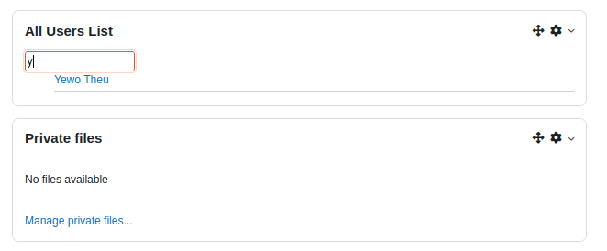

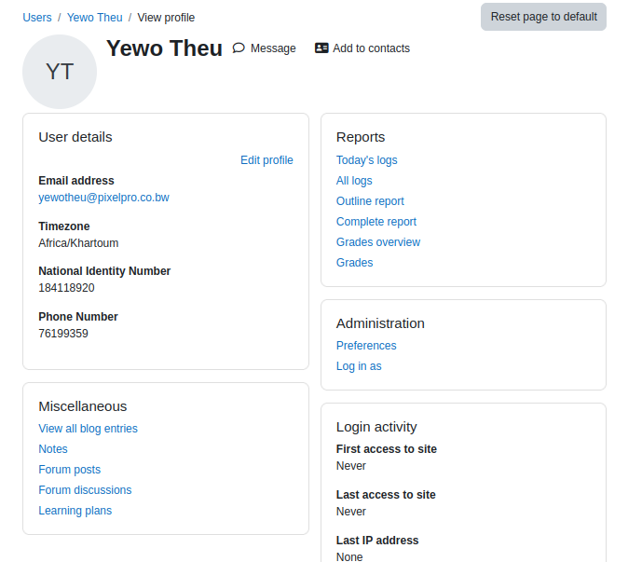

Use the browser function to print.